**Exercise 3: Stored Procedures**

Step 1: Create accounts table

CREATE TABLE accounts (

account_id NUMBER PRIMARY KEY,

customer_id NUMBER,

account_type VARCHAR2(20),

balance NUMBER

);

Insert sample values

INSERT INTO accounts VALUES (201, 1, 'Savings', 10000);

INSERT INTO accounts VALUES (202, 2, 'Current', 15000);

INSERT INTO accounts VALUES (203, 3, 'Savings', 20000);

COMMIT;

* SELECT * FROM ACCOUNTS;

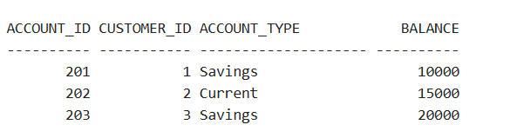

Step 2: Create employees table

CREATE TABLE employees (

emp_id NUMBER PRIMARY KEY,

emp_name VARCHAR2(50),

department VARCHAR2(50),

salary NUMBER

);

Insert sample values

INSERT INTO employees VALUES (301, 'David', 'Finance', 50000);

INSERT INTO employees VALUES (302, 'Emma', 'IT', 60000);

INSERT INTO employees VALUES (303, 'Olivia', 'Finance', 55000);

COMMIT;

* SELECT * FROM EMPLOYEES;

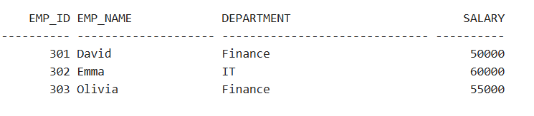

**Scenario 1:** The bank needs to process monthly interest for all savings accounts.

* + **Question:** Write a stored procedure **ProcessMonthlyInterest** that calculates and updates the balance of all savings accounts by applying an interest rate of 1% to the current balance.

CREATE OR REPLACE PROCEDURE ProcessMonthlyInterest AS

BEGIN

UPDATE accounts

SET balance = balance + (balance * 0.01)

WHERE account_type = 'Savings';

COMMIT;

DBMS_OUTPUT.PUT_LINE('Monthly interest applied to all savings accounts.');

END;

/

SET SERVEROUTPUT ON;

EXEC ProcessMonthlyInterest;

SELECT * FROM accounts;

**OUTPUT:**

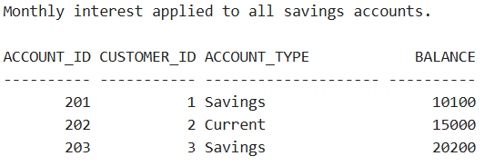

**Scenario 2:** The bank wants to implement a bonus scheme for employees based on their performance.

* + **Question:** Write a stored procedure **UpdateEmployeeBonus** that updates the salary of employees in a given department by adding a bonus percentage passed as a parameter.

CREATE OR REPLACE PROCEDURE UpdateEmployeeBonus (dept_name IN VARCHAR2,

bonus_pct IN NUMBER) AS

BEGIN

UPDATE employees

SET salary = salary + (salary * bonus_pct / 100)

WHERE department = dept_name

COMMIT;

DBMS_OUTPUT.PUT_LINE('Bonus applied to ' || dept_name || ' department.');

END;

/

EXEC UpdateEmployeeBonus('Finance', 10);

SELECT * FROM employees;

**OUPUT:**

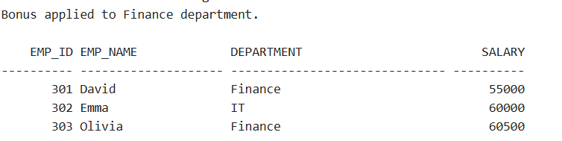

**Scenario 3:** Customers should be able to transfer funds between their accounts.

* + **Question:** Write a stored procedure **TransferFunds** that transfers a specified amount from one account to another, checking that the source account has sufficient balance before making the transfer.

CREATE OR REPLACE PROCEDURE TransferFunds (

from_acc IN NUMBER,

to_acc IN NUMBER,

amount IN NUMBER

) AS

from_balance NUMBER;

BEGIN

-- Get source account balance

SELECT balance INTO from_balance

FROM accounts

WHERE account_id = from_acc;

-- Check sufficient balance

IF from_balance >= amount THEN

-- Deduct from source

UPDATE accounts

SET balance = balance - amount

WHERE account_id = from_acc;

UPDATE accounts

SET balance = balance + amount

WHERE account_id = to_acc;

COMMIT;

DBMS_OUTPUT.PUT_LINE('Transfer successful: ' || amount || ' transferred from Account ' || from_acc || ' to Account ' || to_acc);

ELSE

DBMS_OUTPUT.PUT_LINE('Insufficient balance in Account ' || from_acc);

END IF;

END;

/

EXEC TransferFunds(201, 203, 2000);

SELECT * FROM accounts;

**OUTPUT:**

